

***INSTITUTE OF INFORMATION TECHNOLOGY***

***JAHANGIRNAGAR UNIVERSITY***

**Number of Lab Report :** 04

**Name of Lab Report :** Ring counter with D flipflop.

**Course Tittle :** Digital Logic Design Lab

**Course Code :** ICT – 2104

**Submission Date :** 18/02/2021

**Submitted To Submitted By**

[Dr. Md. Sazzadur Rahman](https://juniv.edu/teachers/rhemel) MD. Shakil Hossain

Associate Professor Roll – 2023

IIT – JU 2nd year 1st Semester

IIT – JU

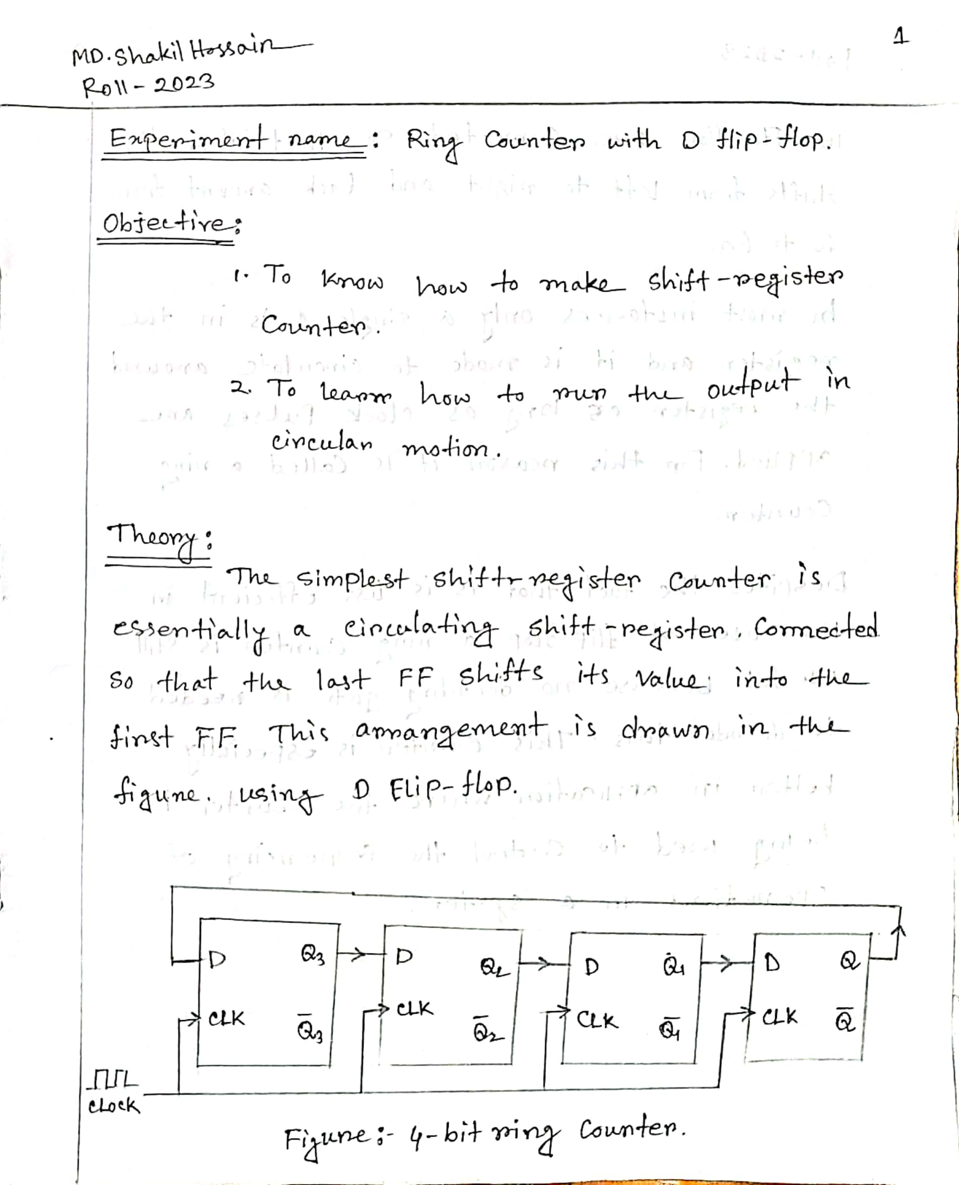

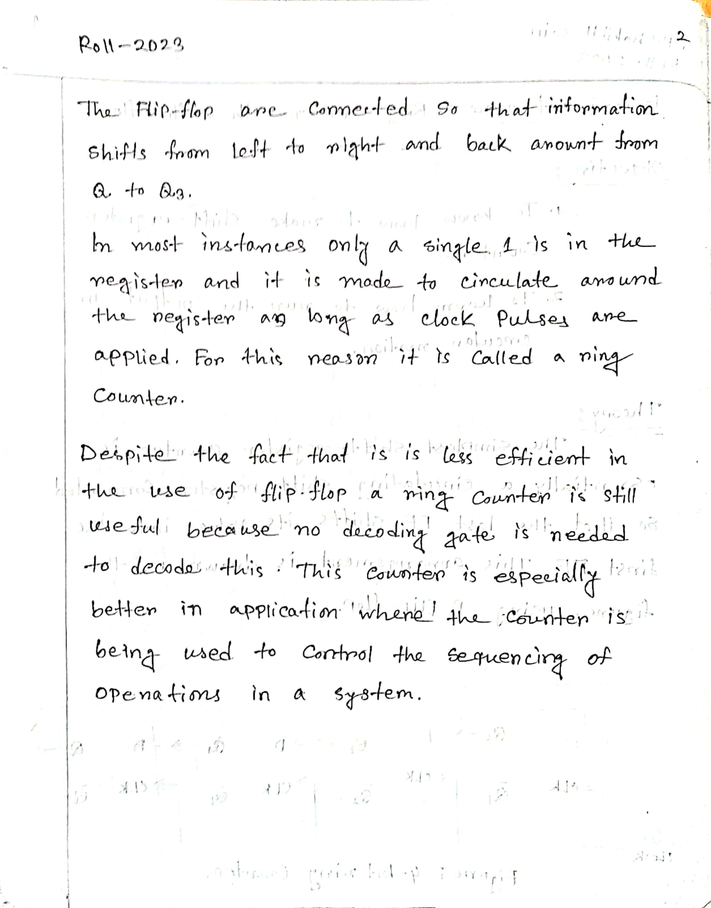

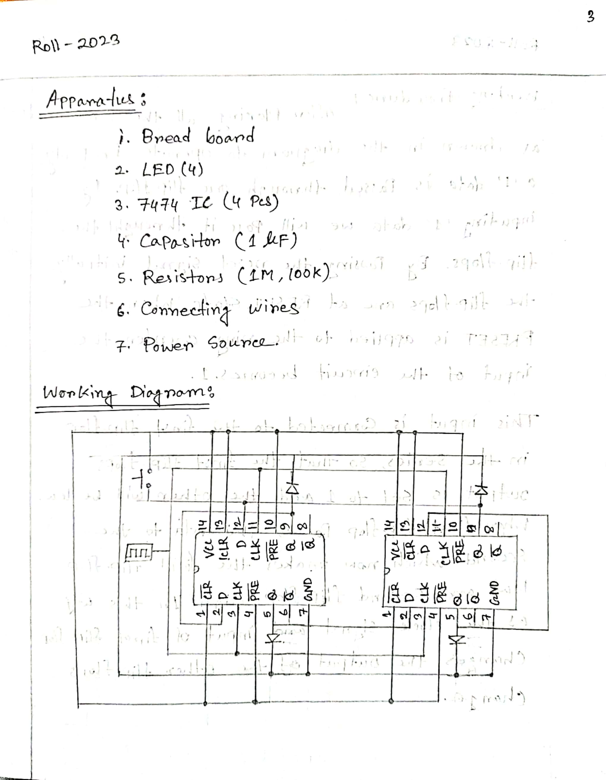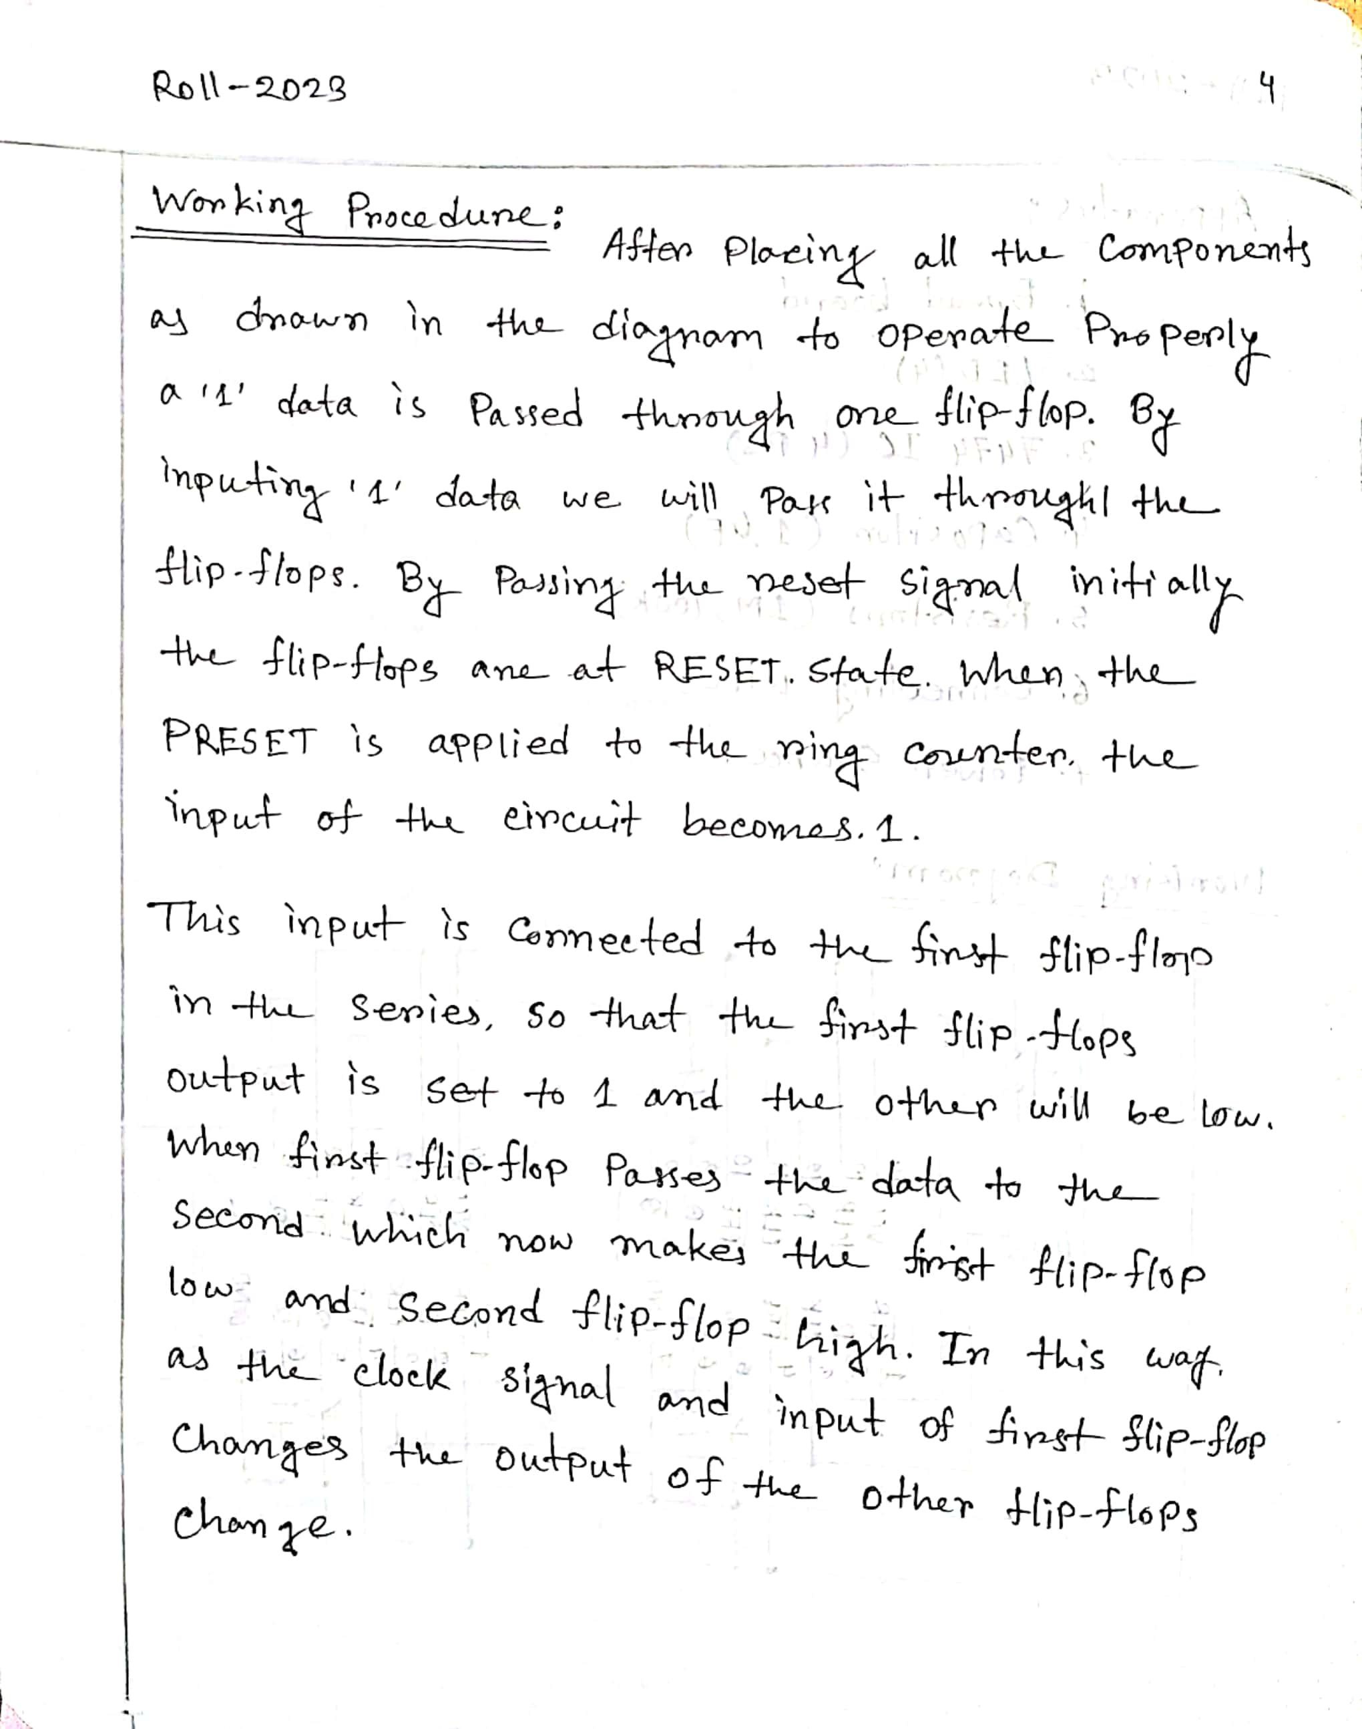

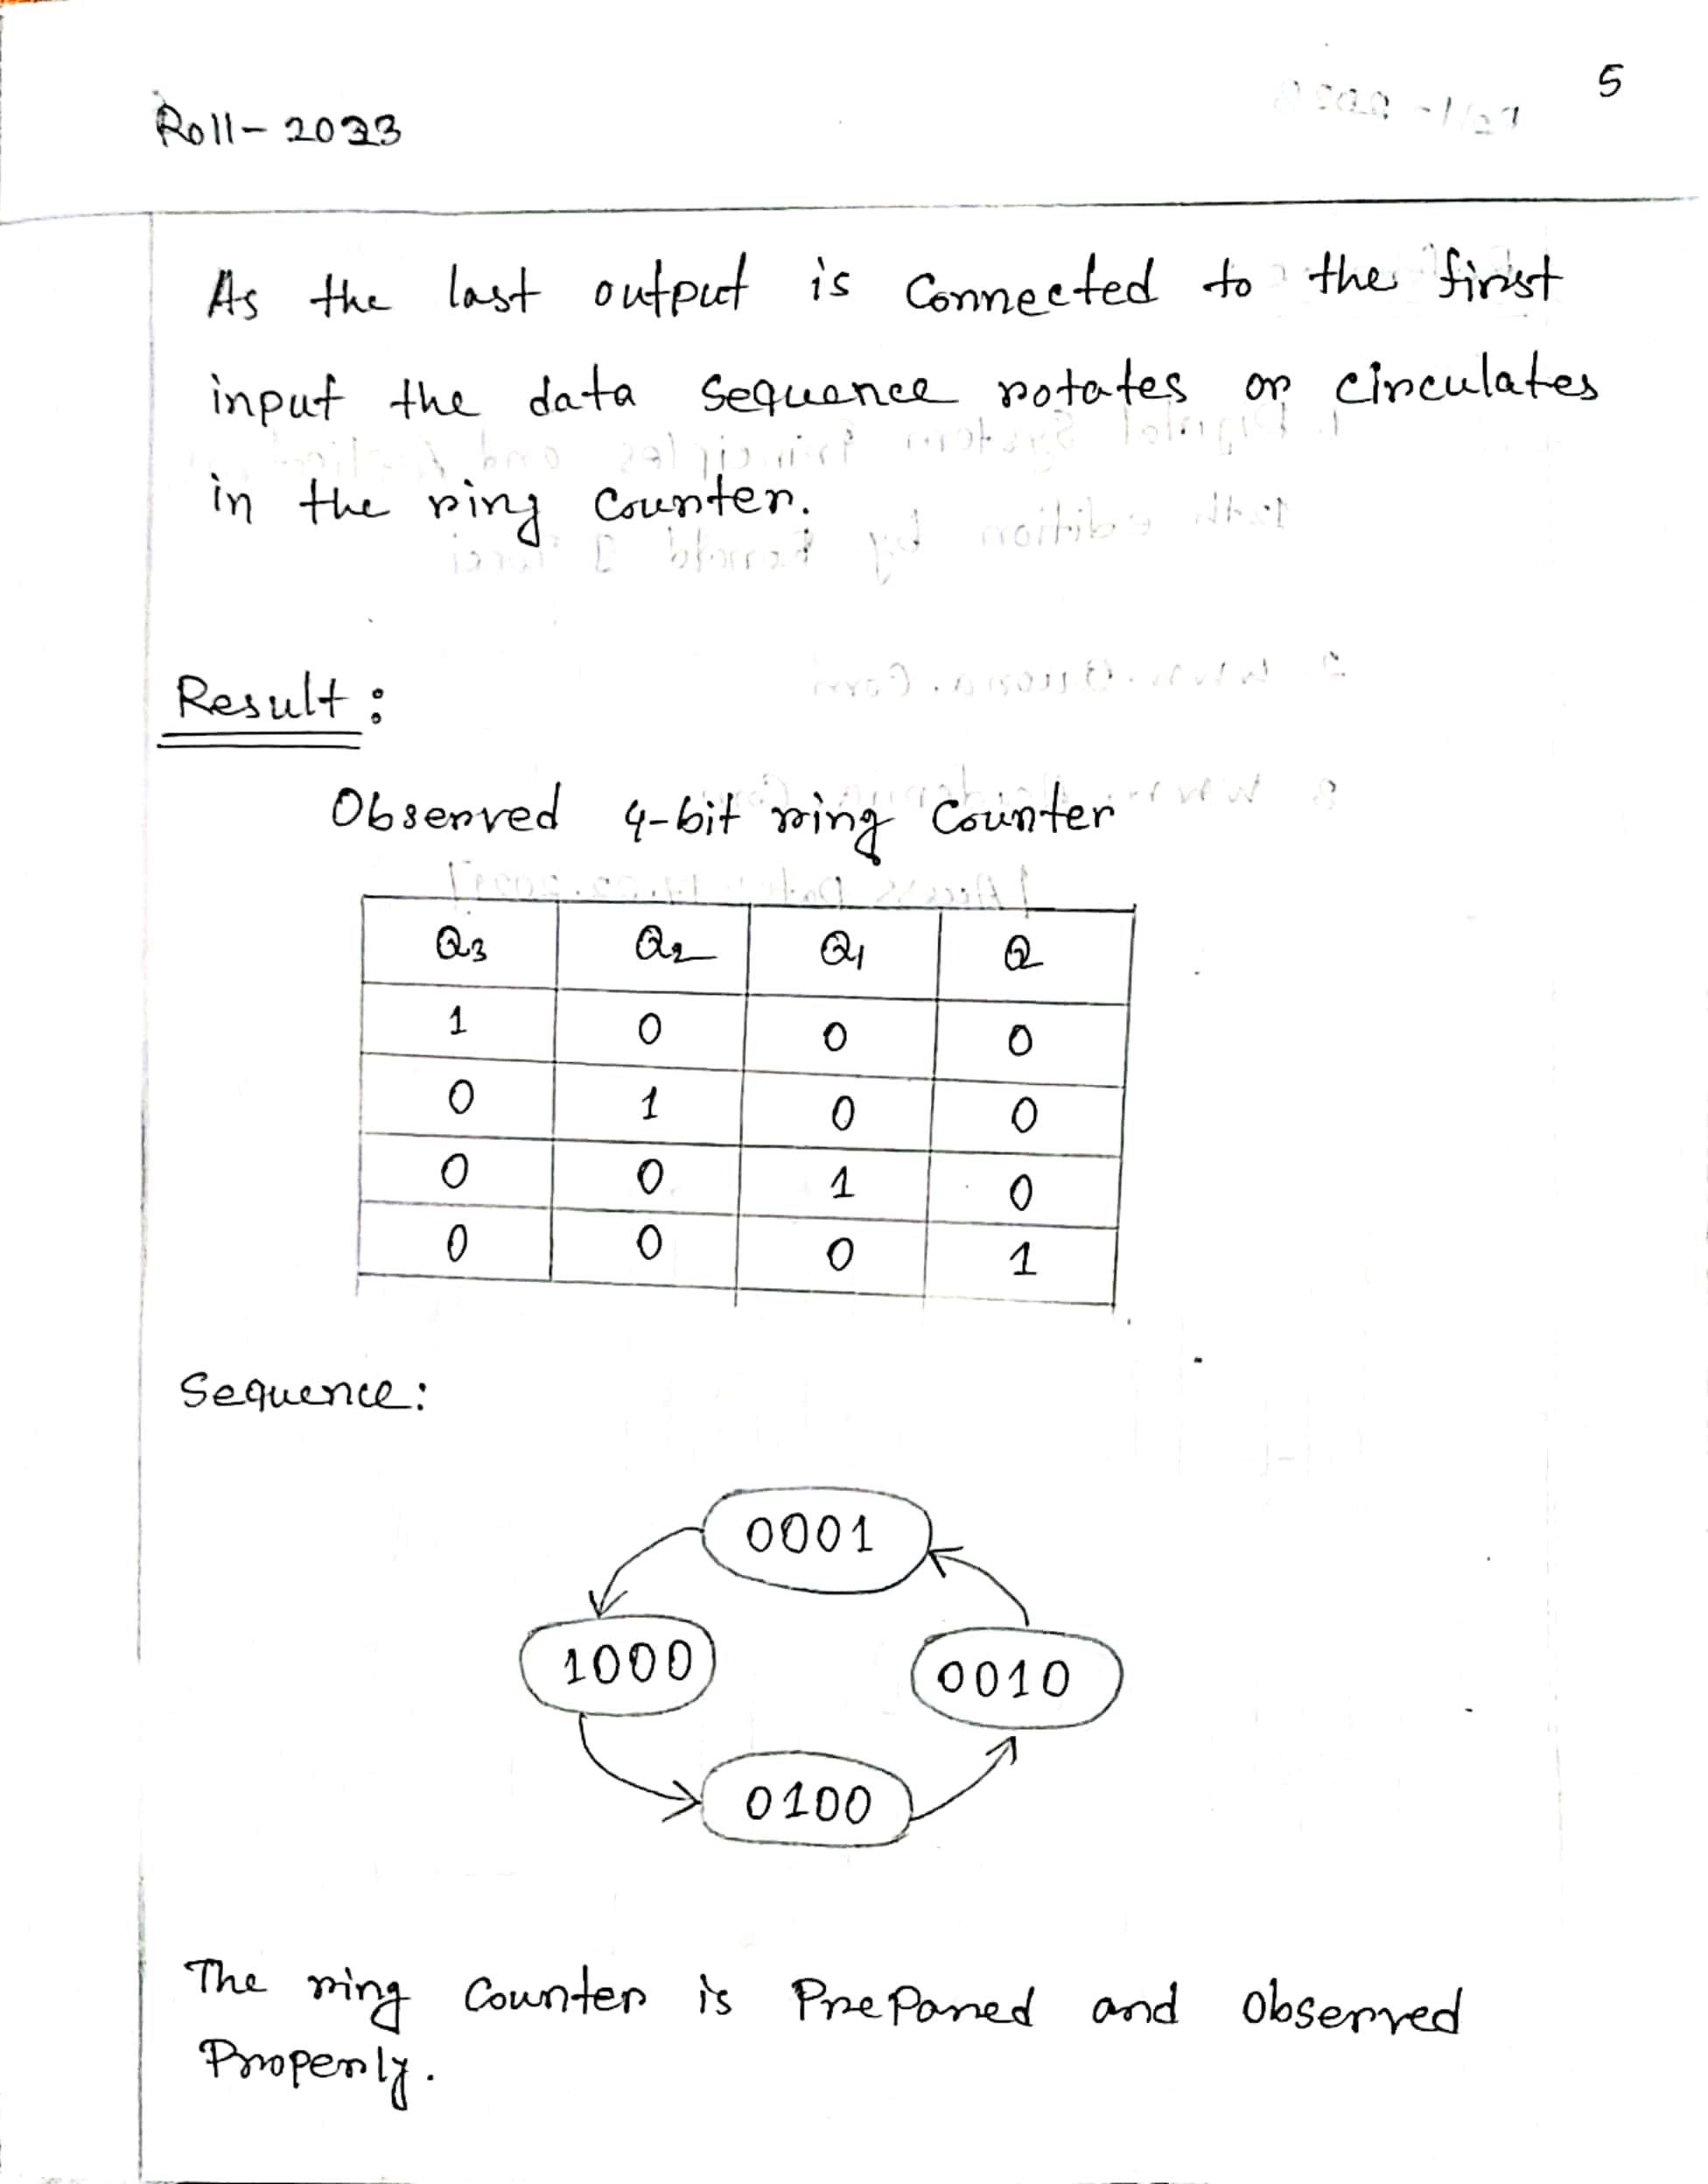

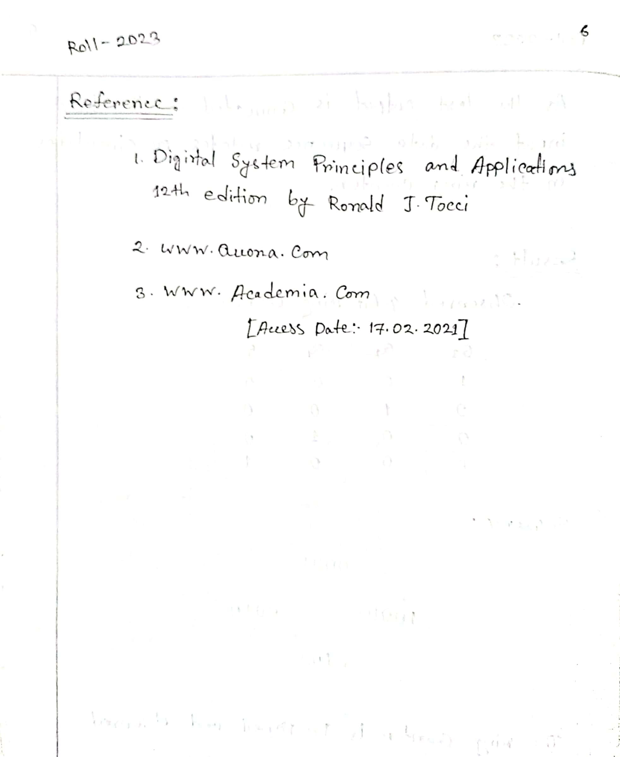

**THE END**